**CASE STUDY FOR BANK QUEUING MODEL**

ANAMIKA AGRAWAL1

*(Department of computer science, JK Lakshmipat University, Jaipur)*

Abstract: Waiting lines and service efficiency are the important elements for any bank. Queuing is the common activity of customers or people to avail the desired service, which could be processed or distributed one at a time. Queuing theory has been fairly a successful tool in the performance analysis of waiting lines. In this paper, an optimized model is proposed to improve the bank queuing system based on queuing theory. This method can optimize the number of server and improve the service efficiency that could effectively cut down service costs and customer’s waiting time. The service time needs to be improved to maintain the customers. This paper shows that the queuing theory used to solve this problem. We obtain the data from the SBI bank in Jaipur city. We then derive the arrival rate, service rate, utilization rate, waiting time in the queue and the average number of customers in the queue based on the data using Little’s theorem and M/M/I queuing model We conclude the paper by discussing the benefits of performing queuing analysis to a busy bank.

Keywords: Bank , Little’s theorem, M/M/I queuing model, Queue, Waiting lines.

**1.INTRODUCTION**

Waiting lines or queues is the major source of difficulties to any organisation or service provider institutes like hospitals, banks etc. Queue is a common word that means a waiting line or the act of joining a line. Queuing theory was initially proposed by A.K. Erlang in 1903. Queuing theory basically a mathematical approach, used for the analysis of waiting lines. It deals with the problems that involve waiting (or queuing). Queuing theory is used to analysing the congestions and delays of waiting in line. It optimizes the number of service facilities and adjusts the times of services . Queuing theory is the study of queue or waiting lines. Some of the analysis that can be derived using queuing theory include the expected waiting time in the queue, the average time in the system, the expected queue length as well as the probability of the system to be in certain states, such as empty or full. This paper uses queuing theory to study the waiting lines in SBI BANK at Jaipur city, Rajasthan. In ATM, bank customers arrive randomly and the service time is also random. We use Little’s theorem and M/M/I queuing model to derive the arrival rate, service rate, utilization rate, waiting time in the queue. On average 150 customers are served in a day.

**2. QUEUING SYSTEM**

A queuing system can be completely described by

i) the input or arrival pattern (customers);

ii) the service mechanism (service pattern);

iii) the queue discipline &

iv) customer’s behaviour

The diagrammatic representation of the above components of queuing system is shown below-

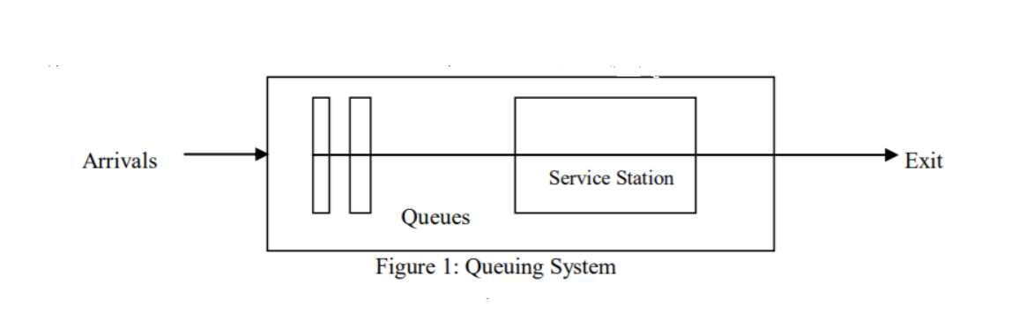

Here the queuing system is the Bank Service System. The following assumptions were made for the queuing system at the SBI Bank Jaipur, in accordance with the queuing theory

• Poisson arrival rate of λ customers per unit of time.

• Exponential service times of µ customer per unit of time.

• Queue discipline is first come first served basis by any of the server.

• The waiting line has two or more identical servers.

• There is no limit to the number of the queue (infinite).

• The average arrival rate is greater than average service rate.

**3. QUEUING THEORY**

***3.1 LITTLE’S THEOREM***

Little’s theorem describes the relationship between throughput rate (i.e. arrival & service rate), cycle time and work in process (i.e. number of customers/jobs in the system). The theorem states that the expected number of customers (N) for a system in steady state can be determined using the following equation:

L = λT

Here, λ is the average customer arrival rate and T is the average service time for a customer.

Three fundamental relationships can be derived from Little’s theorem-

• L increases if λ or T increases

• λ increases if L increases or T decreases

• T increases if L increases or λ decreases

***3.2 BANK Model (M/M/I queuing model)***

M/M/1 queuing model means that the arrival and service time are exponentially distributed (Poisson process). For the analysis of the BANK M/M/1 queuing model, the following variables will be investigated:

* λ : The mean customers arrival rate
* µ : The mean service rate
* p=λ/ µ : Utilization factor
* Probability of zero customers in the Bank:

Po=1-p

* Pn : The probability of having n customers in the Bank

Pn= Po Pn=(1-p)pn

* L:The average number of customers in the Bank

L=p/(1-p)= λ/ (µ-λ)

* Lq :The average number of customers in the queue
* Lq =L*p = p2/(1-p)
* Wq :The average waiting time in the queue

Wq  =Lq /λ =p/ µ-λ

* W: The average time spent in the Bank, including the waiting time:

W=L/λ =1/ µ -λ

**IV. OBSERVATION & DISCUSSION**

We have collected the one day customer data(by hours) by observation during banking time(10-4).

|  |  |
| --- | --- |
| time | Number of customers |
| 10-11 | 40 |
| 11-12 | 32 |
| 12-1 | 20 |
| 1-2 | 21 |
| 2-3 | LUNCH (0 CUSTOMERS) |
| 3-4 | 25 |

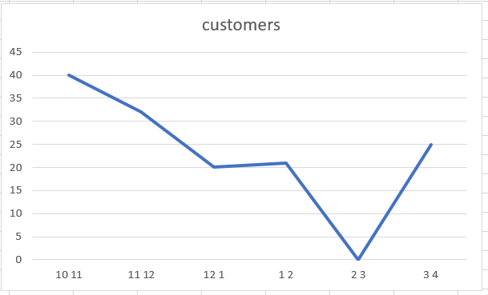

GRAPHICAL REPRESENTATION

From the above figure, we observe that, the number of customers at 10-11 is double the number of customers at 12-1. The busiest period for the bank is 10-11. Hence, the time period is very important for the research. We also observe that after 12 customer decreases maybe because of the hotness during the day time.

**4.1 Calculation**

Arrival rate(λ) is 23 per hour.

And average time to serve each customer is 7 mins.

µ=7mins=9/hr

Expected waiting time in a queue E(Wq)= λ/ µ(µ-λ)

= 23/9(23-9)

=23/14

=1.64/hr.

Expected waiting time in a system E(Ws)=1/ µ -λ

=1/23-9

=1/14 per hr.

**4.2 Conclusion**

This case study has discussed the application of queuing theory to the Bank . From the result we have obtained that, the rate at which customers arrive in the queuing system is 23 customers per hour and the service rate is 7minute per hour for one customer. The expected waiting time in a queue is 1.64/hr. and expected waiting tine in a system is 1/14 per hr. This theory is also applicable for the bank ATM , if they want to calculate all the data daily and this can be applied to all branch also. The constraints that were faced for the completion of this research were the inaccuracy of result since some of the data that we use was just based on assumption or approximation. We hope that this case study can contribute to the betterment of a bank in terms of its functioning.